Switch tong:

Ip routing

spanning-tree mode pvst

spanning-tree vlan 1,10,20,30,40,50,60,99 priority 0

Ip domain mname tmp (?)

Int fa0/6

No switchport

Ip add 192.168.102.1 255.255.255.0

Duplex auto

Speed auto

Int range fa0/1-2

Switchport trunk native vlan 99

Switchport trunk encapsulation dot1q

Switchport mode trunk

Int range fa0/3-5

Switchport mode access

Switchport access vlan 99

Vlan 10

Vlan 20

Vlan 30

Vlan 40

Vlan 50

Vlan 60

Vlan 99

Int vlan 10

Ip add 192.168.10.1 255.255.255.0

Ip helper-address 192.168.99.2

Int vlan 20

Ip add 192.168.20.1 255.255.255.0

Ip helper-add 192.168.99.2

Int vlan 30

Ip add 192.168.30.1 255.255.255.0

Ip helper-add 192.168.99.2

Int vlan 40

Ip add 192.168.40.1 255.255.255.0

Ip helper-add 192.168.99.2

Int vlan 50

Ip add 192.168.50.1 255.255.255.0

Ip helper-add 192.168.99.2

Int vlan 60

Ip add 192.168.60.1 255.255.255.0

Ip helper-add 192.168.99.2

Int vlan 99

Ip add 192.168.99.1 255.255.255.0

Ip default-network 192.168.99.0

Ip route 0.0.0.0 0.0.0.0 fa0/6

Switch 3 tang tren:

Ip domain name tmp (?)

Spanning-tree mode pvst

Spanning-tree vlan 1,10,20,30,40,50,60,99 priority 4096

Int range fa0/1-14

Switchport trunk native vlan 99

Switchport trunk en dot1q

Switchport mode trunk

Vlan 10

Vlan 20

Vlan 30

Vlan 40

Vlan 50

Vlan 60

Vlan 99

Int vlan 99

Ip add 192.168.99.10 255.255.255.0

Ip default-network 192.168.99.0

Switch 3 tang duoi:

Ip domain name tmp (?)

Spanning-treen mode pvst

Spanning-tree vlan 1,10,20,30,40,50,60,99 priority 4096

Int range fa0/1-12

Switchport trunk native vlan 99

Switchport trunk en dot1q

Switchport mode trunk

Vlan 10

Vlan 20

Vlan 30

Vlan 40

Vlan 50

Vlan 60

Vlan 99

Int vlan 99

Ip add 192.168.99.20 255.255.255.0

Ip default-network 192.168.99.0

Switch 0 (2,3,5):

Ip domain name tmp (?)

Spanning-tree mode pvst

Spanning-tree extend system-id

Spanning-tree vlan 1,10,20,30,40,50,60,99 priority 8192

Int fa0/17

Switchport trunk native vlan 99

Switchport mode trunk

Int range fa0/1-16

Switchport mode access

Switchport access vlan 10 (20)

Int vlan 99

Ip add 192.168.99.101 (102) 255.255.255.0

Ip default-gateway 192.168.99.1

Switch 1 (4):

Ip domain name tmp (?)

Spanning-tree mode pvst

Spanning-tree extend system-id

Spanning-tree vlan 1,10,20,30,40,50,60,99 priority 8192

Int fa0/10

Switchport trunk native vlan 99

Switchport mode trunk

Int range fa0/1-8

Switchport mode access

Switchport access vlan 10 (20)

Int vlan 99

Ip add 192.168.99.101 (102) 255.255.255.0

Ip default-gateway 192.168.99.1

Switch 6 (7,8,9,10,11,12,13,14,15,16,17):

Ip domain name tmp (?)

Spanning-tree mode pvst

Spanning-tree extend system-id

Spanning-tree vlan 1,10,20,30,40,50,60,99 priority 8192

Int fa0/14

Switchport trunk native vlan 99

Switchport mode trunk

Int range fa0/1-13

Switchport mode access

Switchport access vlan 30 (40)

Int vlan 99

Ip add 192.168.99.103 (104) 255.255.255.0

Ip default-gateway 192.168.99.1

Switch 18 (19,20,21):

Ip domain name tmp (?)

Spanning-tree mode pvst

Spanning-tree extend system-id

Spanning-tree vlan 1,10,20,30,40,50,60,99 priority 8192

Int fa0/19

Switchport trunk native vlan 99

Switchport mode trunk

Int range fa0/1-18

Switchport mode access

Switchport access vlan 50 (60)

Int vlan 99

Ip add 192.168.99.105 (106) 255.255.255.0

Ip default-gateway 192.168.99.1

DHCP-DNS server:

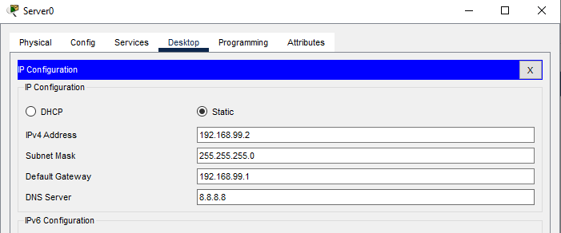

Tuong tu cho cac vlan 50 va 60

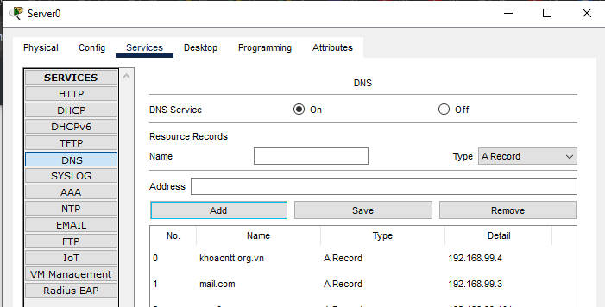

Router noi voi switch tong:

Spanning-tree mode pvst

Int gi0/0/0

Ip add 192.168.102.2 255.255.255.0

No sh

Duplex auto

Speed auto

Int gi0/0/1

Ip add 192.168.103.1 255.255.255.0

No sh

Duplex auto

Speed auto

Ip route 192.168.99.0 255.255.255.0 gi0/0/0

Ip route 192.168.10.0 255.255.255.0 gi0/0/0

Ip route 192.168.20.0 255.255.255.0 gi0/0/0

Ip route 192.168.30.0 255.255.255.0 gi0/0/0

Ip route 192.168.40.0 255.255.255.0 gi0/0/0

Ip route 192.168.50.0 255.255.255.0 gi0/0/0

Ip route 192.168.60.0 255.255.255.0 gi0/0/0

Ip route 0.0.0.0 0.0.0.0 gi0/0/1

Internet:

Spanning-tree mode pvst

Int loopback 0

Ip add 8.8.8.8 255.255.255.255

Int gi0/0/0

Ip add 192.168.103.2 255.255.255.0

No sh

Duplex auto

Speed auto

Ip route 192.168.99.0 255.255.255.0 gi0/0/0

Ip route 192.168.10.0 255.255.255.0 gi0/0/0

Ip route 192.168.20.0 255.255.255.0 gi0/0/0

Ip route 192.168.30.0 255.255.255.0 gi0/0/0

Ip route 192.168.40.0 255.255.255.0 gi0/0/0

Ip route 192.168.50.0 255.255.255.0 gi0/0/0

Ip route 192.168.60.0 255.255.255.0 gi0/0/0